IT446- Data Mining and Data Warehousing

Assignment # 3
  - Deadline: Thursday 27/04/2017 @ 23:59
[Total Mark for this Assignment is 4]

Instructions:
- This Assignment must be submitted on Blackboard via the allocated folder.
- Email submission will not be accepted.
- You are advised to make your work clear and well-presented, marks may be reduced for poor presentation.
- You MUST show all your work.
- Late submission will result in ZERO marks being awarded.
- Identical copy from students or other resources will result in ZERO marks for all involved students.
- Submit this assignment in MS WORD format.
Student Details:
Name: ###  CRN: ### |  | ID: ###

Question One
1.5 Mark
Learning Outcome(s):
- Examine decision tree induction.

The following decision tree has been created for loan approval.

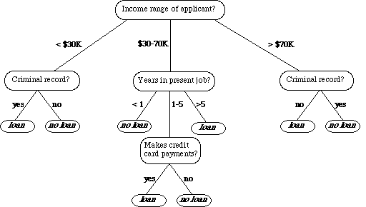

- Convert this tree to if then rules (0.5)

- Using the following testing data:

- Predict the class of each record (0.25)

 | Income range of applicant | Criminal record | Years in present job | Makes credit card payments | Class | Prediction
1 | $25K | no | 6 | no | loan
2 | $40K | yes | 2 | yes | loan
3 | $80K | no | 7 | yes | No loan
4 | $55K | no | 8 | no | No loan

- Calculate the accuracy of this model. (0.25)

- Interpret the obtained result (0.25)

- How we can improve the performance of the obtained model? (0.25)

Question Two
0.5 Mark
Learning Outcome(s):
- Examine algorithms such as: backpropagation; and support vector machine.

Compare neural networks and SVM techniques. What do they have in common and what are the major differences?
Answer:

Question Three
2 Marks
Learning Outcome(s):
Clustering

We can represent a data set as a collection of object nodes and a collection of attribute nodes, where there is a link between each object and each attribute, and where the weight of that link is the value of the object for that attribute. For sparse data, if the value is 0, the link is omitted. Bipartite clustering attempts to partition this graph into disjoint clusters, where each cluster consists of a set of object nodes and a set of attribute nodes. The objective is to maximize the weight of links between the object and attribute nodes of a cluster, while minimizing the weight of links between object and attribute links in different clusters. This type of clustering is also known as co-clustering since the objects and attributes are clustered at the same time.
- How is bipartite clustering (co-clustering) different from clustering the sets of objects and attributes separately?
- Are there any cases in which these approaches yield the same clusters?
Answer:

